2.5 Partial Orderings
A relation R on a set S is a partial ordering if it satisfies all three of the following properties.
- Reflexivity. For any $a∈S, aRa$
- Transitivity. For any $a, b,c∈S, if aRb and bRc, then aRc$.
- Antisymmetry. For any $a,b∈S, if aRb and bRa, then a=b$.
For example, if S is a set of numbers, then $≤$ defines a partial ordering on S.
Because this operator is a natural example of a partial ordering, we often use the symbol $≺$ to represent a generic partial ordering relation (instead of R). This notation has the advantage of allowing us to write $a≺b when a$ $≺$ $b$ and $a≠b$.
Another example: Let S be any set, and let P(S) be the power set of S. Then $⊆$ defines a partial ordering on P(S).
Proof: Let $A∈P(S)$. Then $A⊆A$, since $x∈A$ obviously implies $x∈A$. So $⊆$ is reflexive.
Let $A, B, C∈P\left(S\right), and suppose A⊆B and B⊆C$. Then for all $x∈S, x∈A ⇒x∈B and x∈B ⇒x∈C, so x∈A ⇒x∈C$. Thus $A⊆C$, so $⊆$ is transitive.
Finally, let $A, B∈P(S)$, and suppose that $A⊆B and B⊆A$. Then $x∈A ⟺x∈B$, so A=B. Therefore, $⊆$ is antisymmetric.

If a set X has a partial ordering $≺$ on it, we say that $(X,$ $≺$ ) is a partially ordered set, or poset, for short. In a poset, it is possible to have elements a and b such that neither $a$ $≺$ b nor $b$ $≺$ a. Such elements are called incomparable. For example, the "divides" relation | defines a partial ordering on N. In that poset, 12 and 25 are incomparable because $12∤25$ and $25∤12$.
If a poset has no incomparable elements, it is called a total ordering. For example, the real numbers R are totally ordered by the $≤$ relation.

Partial orderings define a hierarchy among the elements of a set. We use Hasse Diagrams to describe this hierarchy graphically. Suppose $≺$ is a partial ordering on a set X. A Hasse diagram for $(X,$ $≺$ ) consists of a label, or node, for each element in the set, along with lines connecting related nodes. More specifically, if x, y are distinct elements of X with $x≺$ y and there are no elements z such that $x≺z≺y$, then there should be an upward sloping line from node x to node y in the Hasse diagram.
Example 1: Let $T=\{1,2,3\}$ and consider the poset $(P\left(T\right), ⊆)$. Draw the Hasse diagram for this poset.
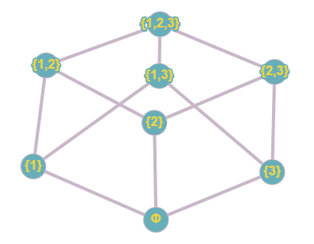
***Note, when we draw Hasse Diagrams, there are TWO important rules!
- We don't use arrows. Instead, it is ALWAYS assumed the relations travel from bottom to top. So it's VERY IMPORTANT where you place the vertices in Hasse Diagrams. For example in this one, since {1} is lower than {1,2}, we know that they're connection tells us that $\left\{1\right\}⊆\{1,2\}$ and not the other way around. If two elements are not related, it doesn't matter which one is placed higher. For example, {1} and {3} are not related in either direction, so it doesn't matter if one is placed above or below the other.
- We don't draw shortcuts. For example, in this problem. It is true that $\left\{1\right\}⊆\{1,2,3\}$ but because $\left\{1\right\}⊆\left\{1,2\right\} and \left\{1,2\right\}⊆\left\{1,2,3\right\}$, we don't draw the line on a Hasse diagram. If you're looking at the diagram, think of it this way. Travelling from bottom to top, since we can start at {1} and trace along to get to {1,2,3}, we don't need the direct line.

Example 2: Let $X=\{2,3,4,6,8\}$, and say two elements $a,b∈X$ are related if $a|b$. Draw the Hasse diagram for $(X,|)$
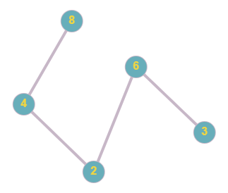
A partial ordering on a set gives you a way of comparing elements and ranking them. In this ranking system, there are often least elements and greatest elements. If $(X,$ $≺$ ) is a poset, we say that an element $m∈X$ is minimal if there is no $x∈X (x≠m)$ such that $x$ $≺$ m. Similarly, we say that an element $M∈X$ is maximal if there is no $x∈X (x≠M)$ such that $≺x$. For example, in the previous example, 2 and 3 are the minimal elements and the maximal elements are 6 and 8. In the example before it, $∅$ is minimal and $\{1,2,3\}$ is maximal.

HOMEWORK: #3-15, 19

